**COUPON99**

**A Project Report**

Submitted in partial fulfilment of the

Requirements for the award of the Degree of Information technology

**BACHELOR OF SCIENCE (INFORMATION TECHNOLOGY)**

**By**

Ansari Hamid Mohammad Ansar

Roll no : 05/23



**Under the esteemed guidance of**

**Mrs. Harpreet Kaur**

**DEPARTMENT OF INFORMATION TECHNOLOGY**

**GURUNANAK COLLAGE OF ARTS, SCIENCE & COMMERCE**

**(***Affiliated to university of Mumbai)*

**MUMBAI 400037**

**MAHARASHTRA**

**2022-2023**

**PROFORMA FOR THE APPROVAL PROJECT PROPOSAL**

**(*Note: All entries of the proforma of approval should be filled up with appropriate and***

***Complete information. Incomplete proforma of approval in any respect will be***

***Summarily rejected.)***

**PRN NO**: 2021016401194276 **Roll no:** 05

1. **Name of student :** Ansari Hamid Mohamad Ansar
2. **Title of the project :** COUPON99
3. **Name of the Guide :** Mrs. Harpreet Kaur
4. **Teaching experience of the Guide** **:** Excellent
5. **Is this your first submission? Yes** ✔ **No**

Signature’s of the student Signature of the Guide

Date: …………………… Date: ……………………

Signature of the Co-ordinator

Date: ……………….

**GURUNANAK COLLAGE OF ARTS SCIENCE AND COMMERCE**

*(Affiliated to**University of Mumbai)*

**MUMBAI-MAHARASHTRA-400037**



**CERTIFICATE**

This is to certify that the project entitled, " **COUPON 99** ", is bonafied work of **ANSARI HAMID MOHAMAD ANSAR** bearing Seat.No: **(2025836)** submitted in partial fulfillment of the requirements for the award of degree of BACHELOR OF SCIENCE in INFORMATION TECHNOLOGY from University of Mumbai.

**Internal Guide (Mrs. Harpreet Kaur)** **Coordinator**

**External Examiner**

**Date: College Seal**

**ABSTRACT**

"Coupons99: Simplifying Coupon Savings for Everyone"

Picture having a stash of digital coupons, each promising to save you money, but managing them feels like a puzzle. Enter Coupons99, your user-friendly destination to effortlessly discover, trade, and benefit from digital payment coupons.

This platform is designed for ease. Users can create accounts, explore a diverse array of coupons, and efficiently select those tailored to their preferences. Furthermore, Coupons99 keeps your savings up-to-date with timely expiry reminders and spotlights the best deals right on the homepage.

Utilizing top-notch software, Coupons99 ensures a seamless experience across devices. It's armed with features like user profiles, advanced search options, real-time notifications, and user reviews, all while keeping data secure and supporting multiple languages.

Future plans include secure payment options, seller verification, analytics tools, comprehensive customer support, and location-based deals. In essence, Coupons99 isn't just a website; it's a commitment to enhancing your coupon experience, making saving money simpler, and fostering trust in digital coupon trading. Join us and discover the future of coupon savings!

**ACKNOWLEDGEMENT**

We would like to extend our heartfelt gratitude to all those who have contributed to the development of the project "Coupons99." Without your support, dedication, and expertise, this project would not have been possible.

First and foremost, we would like to thank our team members, Hamid Ansari and Yahiya Shaikh, for their unwavering commitment and hard work throughout this journey. Your collaborative efforts have been instrumental in shaping the project.

We would also like to express our sincere appreciation to our mentors and advisors for their guidance and valuable insights, which have enriched our understanding of the project's scope and objectives.

To our friends and family, thank you for your patience and encouragement during the demanding phases of this project. Your belief in our vision kept us motivated.

Lastly, we acknowledge the support and resources provided by our educational institution, which enabled us to pursue this endeavor.

This project, "Coupons99," is a testament to the power of teamwork, innovation, and determination. We look forward to the exciting journey ahead and the positive impact our project will have on the world of coupon savings.

Thank you all for being part of this remarkable endeavor.

Sincerely,

Hamid Ansari

**DECLARATION**

I here by declare that the project entitled, “**Coupon99**” done **at Guru Nanak College of Arts, Science and Commerce** , has not been in any case duplicated to submit to any other university for the award of any degree. To the best of my knowledge other than me, no one has submitted to any other university.

The project is done in partial fulfillment of the requirement for the award of degree of

**BACHELOR OF SCIENCE (INFORMATION TECHNOLOGY)** to be submitted as final semester project as part of our curriculum.

**Name and Signature of the Student**

**TABLE OF CONTENT**

**Chapter 1: introduction**

* 1. Background 09

1.2 Objectives 09

1.3 Purpose, Scope, and Applicability 10

1.4 Achievements 12

1.5 Conclusion and Future Enhancements 13

**Chapter 2: Survey of Technologies**

2.1 The Tech Behind Digital Coupons 14

2.2 Why We Choose These Technologies 16

2.3 What's Next 17

**Chapter 3: Requirements and Analysis**

3.1 Problem Definition 18

3.2 Requirements Specification 20

3.3 Planning and Scheduling 22

3.4 Software and Hardaware Requirements 24

3.5 Preliminary Product Description 25

3.6 Conceptual Models 28

**Chapter 4: System Design**

4.1 Basic Model 33

4.2 Data Model 35

4.3 Procedural data design 38

4.4 Logical Design 41

4.5 Data Structure Diagram 42

4.6 Algorithms Design 43

4.7 User Interface Design 46

4.8 Security Issues 47

4.9 Test Cases Design 48

Chapter **1**

**Introduction**

**Introduction**

* 1. **Background:**

Online shopping is super popular these days, and lots of people use digital coupons to get discounts and special deals. But there's a problem. There isn't a single place where you can easily buy, sell, and trade these digital coupons. Sometimes, when people get coupons, they can't find the right offers for themselves. And some people have coupons they don't need, which could be useful to others. Our project, "Coupons99," is here to solve this problem by creating a friendly website where you can trade digital coupons without any hassle.

* 1. **Objectives:**

Our main goal is to make a website where you can quickly find and pick the coupons you want. Our website will have all sorts of coupons, like discounts, special deals, and exclusive offers. This way, you can save money when you shop online. But we're not stopping there. Our website will also be a cool place for people who love coupons. In the future, we're planning to add exciting features like a list of the best coupons and an easy way to use gift codes or promo codes. We want to make using coupons easy and fun for everyone.

* 1. **Purpose, Scope, and Applicability**

**Purpose:**

Our project exists because we want to make it easier for you to use coupons when you shop online. We believe that finding and using coupons should be simple and enjoyable. We want to make sure you don't miss out on any discounts or deals. Our website will help you get the most out of your coupons.

* **To Make Online Shopping Easy:** We want to make using coupons as easy as pie. You won't have to spend hours searching for the right coupon or worry about missing out on discounts. Our website will do the hard work for you.
* **To Help You Save:** Who doesn't love saving money? Our project is all about helping you keep more money in your pocket. You'll find awesome deals on our website that you might not find anywhere else.
* **To Create a Friendly Place:** Our website isn't just about coupons; it's also a friendly place for people who love getting a good deal. You'll be part of a community of savvy shoppers.

**Scope:**

Our project covers a lot of ground, just like building a big house. Here's what we're going to do:

* **User-Friendly Website:** We'll build a website that's super easy to use. It's like having a map that guides you to the best coupons. You won't get lost, and you'll quickly find what you need.
* **All Kinds of Coupons:** We'll have coupons for everything—discounts, special deals, exclusive offers, you name it. It's like having a big coupon book with all the best offers inside.
* **Timely Reminders:** We'll remind you when your coupons are about to expire. It's like having a friendly alarm clock saying, "Hey, use this coupon before it's gone!"
* **Featured Coupons:** On our homepage, we'll show you some of the coolest coupons. It's like shining a spotlight on the best items in a store so you won't miss them.
* **Keeping You Updated:** We'll send you messages to keep you in the loop about your coupons. It's like having a friend who tells you all the latest news.
* **Reviews and Ratings:** You can leave reviews and ratings for sellers. It's like checking out restaurant reviews before deciding where to eat. This way, you'll know if someone is trustworthy.

**Applicability:**

Our project is for everyone who shops online and wants to save money with coupons. It's also for people who have extra coupons they don't need and want to help others. Our project makes online shopping more convenient and fun**.**

* **For Shoppers:** If you love shopping online and want to keep more money in your wallet, Coupons99 is for you. We're like your shopping sidekick, helping you find the best deals.
* **For Sellers:** If you have coupons you don't need, you can sell them on our website. It's like passing on a great deal to someone who'll appreciate it.
* **For Coupon Lovers:** If you're passionate about coupons and discounts, you'll find a friendly community here. It's like joining a club of like-minded people who love saving money.
  1. **Achievements**

**Achievements:**

As we've been working on this project, we've achieved quite a few things that we're proud of. We've learned a ton about creating a website that's super user-friendly and makes finding great deals a breeze. We want to share some of the big accomplishments we've made:

* User-Friendly Design: We've designed our website to be easy to use. It's like having a map that shows you exactly where the best coupons are. You won't get lost, and you'll be able to find what you need quickly.
* Helping People Save: Our project is all about helping you save money. Imagine if you had a magical money-saving wand when you shopped online. That's what our website aims to be—a helpful tool for your online shopping adventures.
* Reviews and Ratings: We've built a system that allows people to leave reviews and ratings for sellers. This way, you can see if someone is reliable before you buy from them. It's like reading reviews for a restaurant before you decide to eat there.
* Timely Reminders: We'll remind you when your coupons are about to expire. It's like having a friendly alarm clock that says, "Hey, don't forget to use this coupon before it goes away!"
* Featured Coupons: On our homepage, we'll showcase some of the best coupons. It's like putting a spotlight on the coolest items in a store, so you don't miss them.
* Keeping You Updated: We'll send you messages to keep you in the loop about what's happening with your coupons. It's like having a friend who tells you all the latest news.
  1. **Conclusion and Future Enhancements**

**Conclusion:**

In conclusion, our project, Coupons99, is here to make your online shopping experience better. We want to help you save money and enjoy the benefits of coupons. Our website is all about making it simple and fun to use coupons.

**Future Enhancements:**

In the future, we plan to make our website even cooler. We want to add safe and easy ways to pay for coupons. We'll also check and confirm that the people selling coupons are real. Sellers will have a special place to manage their coupons and see how well they're doing. We'll even give them some fancy reports. If you have questions, we'll have answers in a big FAQ section. And if you need help, we're here for you with customer support. We're also thinking about showing you coupons based on where you live. We're excited about the future of Coupons99!

**Chapter 2**

**Survey of Technologies**

**Exploring Technologies**

In this chapter, we're going to take a closer look at the different technologies that are important for our Coupons99 project. Our goal here is to understand these technologies and explain why we chose them for our project. It's worth mentioning that we'll be adding a payment gateway later, but for now, let's focus on the essential technologies.

**2.1 The Tech Behind Digital Coupons**

The world of digital coupons is exciting and relies on various technologies. Let's explore some key ones:

* **Website Building:** Think of our project as constructing a beautiful and user-friendly house. To achieve this, we rely on essential web development technologies: HTML, CSS, and JavaScript. These three amigos work in harmony to create the visual and interactive aspects of our website. HTML is like the skeleton, providing structure. CSS adds style, making it visually appealing, and JavaScript serves as the brain, making everything function smoothly. In the background, we also need a reliable place to store and manage our coupon data, which is where PostgreSQL and Google Cloud come into play. PostgreSQL acts as the digital storage space for our coupons, while Google Cloud provides the virtual home where our website resides.
* **User Authentication and Security:** Ensuring the safety and privacy of our users is our top priority. Just as you lock your home's door to protect what's inside, we use OAuth and JSON Web Tokens (JWT) to safeguard our users' valuable information. These technologies are like special keys that only allow authorized users access to specific areas. They guarantee the confidentiality and integrity of our users' data, instilling trust in our platform's security.
* **Notification Systems:** Effective communication with our users is paramount to building a strong and engaged community. To achieve this, we employ email and push notification systems. These systems are akin to friendly messengers who deliver important updates and messages to our users. Whether it's a transaction confirmation, a new coupon listing, or other relevant activities, our notification systems ensure that our users stay informed and connected with theCoupons99 experience.
* **Fitting All Screens:** People use different devices, like phones, tablets, and computers, to visit our site. To make sure our website looks good on all of them, we use responsive design techniques. It's like tailoring clothes to fit people of all sizes.

**2.2 Why We Choose These Technologies**

**Software to be Used :**

|  |  |
| --- | --- |
| **FRONT END :** | HTML  CSS JAVA SCRIPT |
| **BACK END DATABASE :** | POSTGRESQL |
| **LANGUAGE USED :** | JAVA |

We thought long and hard about which technologies would work best for our project. Here's why we chose the ones we did:

* **User-Friendly:** HTML, CSS, and JavaScript are easy to use and make our website look great and work smoothly. They're like the paint, furniture, and lights that make a house a comfortable home.
* **Data Management:** PostgreSQL and Google Cloud are reliable and can handle lots of coupon data, like a giant closet that keeps everything organized.
* **User Safety:** OAuth and JWT are like strong locks on our doors, ensuring that only the right people can access our users' data.
* **Communication:** Email and push notifications are like friendly postmen who deliver messages to our users, keeping them in the loop.
* **Access for Everyone:** Responsive design ensures that our website looks good on all devices, making it easy for everyone to use.

**2.3 What's Next**

These technologies are the building blocks of Coupons99, and they fit perfectly with our project's goals. While we're not adding a payment gateway just yet, our current tech setup lays the foundation for creating a user-friendly, secure, and accessible platform for buying and selling coupons. These technologies are like the sturdy pillars holding up our project, and we're excited to see Coupons99 come to life.

**Chapter 3**

**Requirements and Analysis**

**3.1 Problem Definition**

**Problem Definition :**

The main issue we're trying to solve is that there's no one-stop place where people can easily buy, sell, or trade digital payment coupons. This causes problems because people either can't find good deals or end up with coupons they don't need. This project, Coupon99, is here to make it easy for everyone.

**Sub-Problems:**

1. **No Central Place to Trade Coupons:** Right now, there's no single place where people can easily trade their coupons. This means they have to spend a lot of time looking for buyers or sellers.
2. **Not Sure About Coupons:** People often get coupons, but they're not sure what they're really worth, when they expire, or how to use them. This confusion makes coupons less useful.
3. **Unused Coupons and Opportunities:** People get coupons they don't want, and these coupons just sit around. But there are others who might want these unused coupons.

**Sub-Problem Details:**

* + - 1. **No Central Place to Trade Coupons:**
         1. People can't easily find a single place to buy or sell their digital payment coupons. It's a hassle to search for people to trade coupons with.
      2. **Not Sure About Coupons:**
         1. People often don't know how valuable their coupons are, when they expire, or how to use them.
         2. Not having clear information about coupons makes it hard to decide if they're worth using or selling.
      3. **Unused Coupons and Opportunities:**
         1. People often end up with coupons they don't want and don't use.
         2. These unused coupons could be helpful to others who are looking for discounts and deals.
         3. By tackling these smaller issues, we aim to create Coupon99, a website that will make it easy for people to buy, sell, and trade coupons. This will help users access discounts more easily and make better use of their unused coupons.

**3.2 Requirements Specification**

**3.2.1 System Requirements :**

* **User Registration and Profiles**
  + Users should be able to create accounts easily by providing their personal information.
  + Users should be able to enter their name, email, and create a password to register.
  + The current system doesn't have a simple way for users to create accounts, making it inconvenient.
* **Coupon Listings**
  + Users should be able to see all the available coupons for sale.
  + Users can view coupons with details like discount amount, expiration date, and terms.
  + Currently, users need to search on multiple websites, which is time-consuming and frustrating.
* **Coupon Submission**
  + Sellers should be able to add their coupons for sale.
  + Sellers provide coupon details like discount value, expiration date, and category.
  + Currently, sellers don't have a dedicated platform to list their coupons easily.
* **Buying and Selling Coupons**
  + Users must be able to buy and sell coupons securely.
  + Users can make purchases, and sellers can list their coupons for sale.
  + In the existing system, these transactions are scattered across different places, causing confusion.
* **Notifications and Reminders**
  + Users should receive reminders when their coupons are about to expire.
  + Users will get alerts about expiring coupons.
  + In the current system, users often forget about their coupons, missing out on savings.
* **User Reviews and Ratings**
  + Users should be able to leave reviews and ratings for sellers.
  + Users can rate sellers and write comments based on their experiences.
  + The current system lacks a way to provide feedback on sellers' trustworthiness.
* **User Support**
  + Users should have access to customer support for help.
  + Users can ask questions or report issues to a support team.
  + Currently, there is no easy way to get assistance when needed.

**3.2.2 Existing System Operations and Problems**

* **Operation of Existing System**
  + The current system lacks a central platform for coupon trading, leading to scattered and confusing transactions.
* **Problems with the Existing System**
  + Users struggle to find specific coupons efficiently, wasting time.
  + Lack of accountability makes it hard to trust sellers.
  + Users often forget to use coupons before they expire, resulting in missed savings opportunities.

**3.3 Planning and Scheduling**

**3.3.1 GANTT CHART**

|  |  |  |  |  |  |  |  |  |
| --- | --- | --- | --- | --- | --- | --- | --- | --- |
| SRN NO | TASKS | | | | START DATE | | FINISH DATE | DURATION |
| **1** | **PROJECT INITIATION** | | | | 01-08-2023 | | 05-08-2023 | 6 DAYS |
|  |  | | | |  | |  |  |
| **2** | **REQUIIREMENT GATHERING** | | | | 06-08-2023 | | 15-08-2023 | 10 DAYS |
|  |  | | | |  | |  |  |
| **3** | **FEASIBILITY STUDY** | | | | 16-08-2023 | | 25-08-2023 | 10 DAYS |
|  |  | | | |  | |  |  |
| **4** | **PRELIMINARY PRODUCT DISCRIPTION** | | | | 26-08-2023 | | 31-08-2023 | 6 DAYS |
|  |  | | | |  | |  |  |
| **5** | **PLANNING AND SCHEDULING** | | | | 01-09-2023 | | 10-09-2023 | 10 DAYS |
|  |  | | | |  | |  |  |
| **6** | **SYSTEM ANALYSIS** | | | | 11-09-2023 | | 15-10-2023 | 35 DAYS |
|  |  | | | |  | |  |  |
|  |  | | | |  | |  |  |
| **7** | **SYSTEM DESIGN** | | | | 30-10-2023 | | 25-11-2023 | 26 DAYS |
|  |  | | | |  | |  |  |
| **8** | **SYSTEM CODING** | | | | 10-12-2023 | | 05-01-2024 | 26 DAYS |
|  |  |  |  |  |  |  |  |  |
| **9** | **IMPLEMENTATION** | | | | 25-01-2024 | | 24-02-2024 | 30 DAYS |
|  |  |  |  |  |  |  |  |  |
| **10** | **PROJECT REPORT SUBMISSION** | | | | 30-02-2024 | | 01-03-2024 | 2 DAYS |

**3.3.2 PERT CHART**

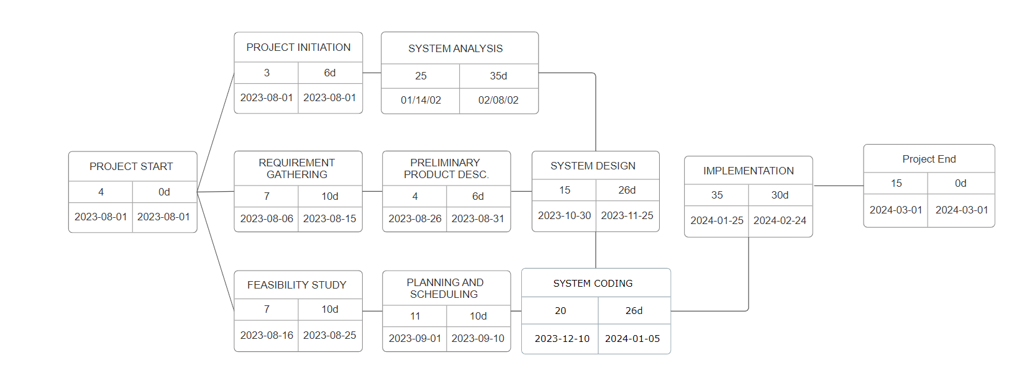

**3.4 Software and Hardaware Requirements**

* **Hardware Requirement:**
  + Considerable disk space for storing website data.
  + Suggested RAM capacity for the server: 16GB or higher.
  + Reliable network infrastructure with sufficient bandwidth.
  + High-performance servers for hosting Coupons99 (for future enhancements).
* **Software Requirements:**
  + Server operating system compatible with web hosting and database management (e.g., Linux, Windows Server).
  + PostgreSQL 42.6.0 for database management.
  + MongoDB for specific data storage.
  + Google Cloud as the web hosting platform.
  + HTML, CSS, and JavaScript (JS) for frontend development.
  + Backend development tools, frameworks, and libraries.
  + Optional user interface frameworks for enhanced design and interactivity if required, (e.g., React, Angular).
  + Security tools, including firewalls and encryption protocols.
  + Version control system (e.g., Git).
  + Integrated Development Environment (IDE) and testing tools.
  + Optional communication and collaboration tools (e.g., Slack, Microsoft Teams).
  + Specific libraries or frameworks for backend development.
  + Optional cloud-based services for scalability, storage, and infrastructure.
  + Web browsers for development and testing.
  + Privacy and security compliance measures.
  + Implementation of multilingual support.
  + Payment gateway integration (for future enhancements).

**3.5 Preliminary Product Description**

**Requirements:**

* Easy-to-Use Website: Make a website that's simple for people to understand and use.
* Coupon Listings: Let people put their coupons up for sale with details like how much discount they offer and when they expire.
* Search and Filters: Help people quickly find the coupons they want by letting them search and use filters.
* User Accounts: Allow people to create accounts where they can manage their coupons and see what they've bought or sold.
* Reminders for Expiring Coupons: Send reminders to users before their coupons expire.
* Featured Coupons: Show some of the best coupons on the website's main page to grab people's attention.
* Real-Time Updates: Tell users when something happens with their coupons, like when they buy or sell one.
* User Ratings and Reviews: Let buyers rate and review sellers based on their experiences.
* Notifications: Send emails when there are new coupons, price changes, or other important updates.
* Sharing on Social Media: Allow users to share coupons they like on social media.
* Works on All Devices: Make sure the website works well on computers, tablets, and phones.
* Privacy and Security: Keep user information and payments safe.
* Support Different Languages: Make the website available in multiple languages.

**Objectives:**

* User-Friendly Platform: Make a website where people can easily find and choose coupons that suit them.
* Offer Many Types of Coupons: Have lots of different coupons, so people can save money in various ways.
* Community for Coupon Fans: Not just a place to buy and sell, but a gathering spot for people who love coupons.
* Better Shopping Experience: In the future, make it easier for people to pick the best coupons and finish their shopping.
* Simple Coupon Redemption: In the future, let users easily use gift codes or promo codes on the website.
* Change How People Use Coupons: Overall, our project wants to make using coupons easier and more enjoyable.

**3.6 Conceptual Models**

**3.6.1 Data Flow Diagram(DFD)**

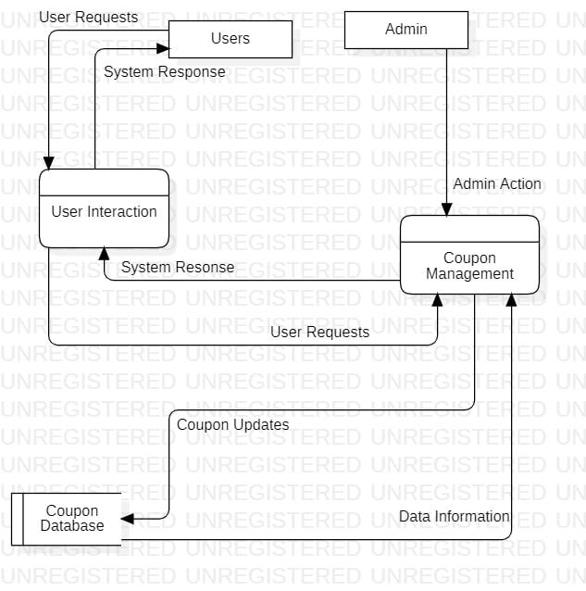

**3.6.2 ER Diagram(ERD)**

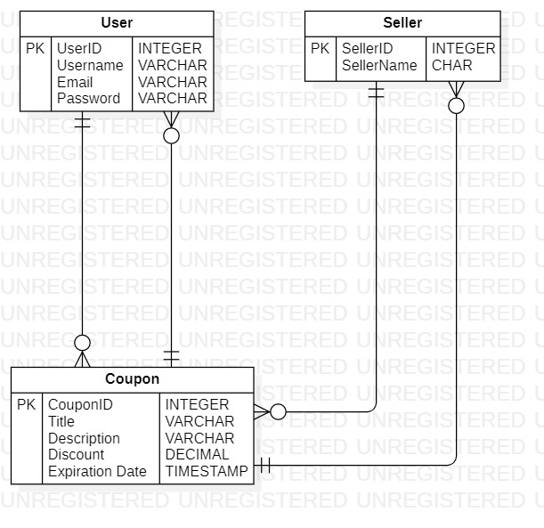

**3.6.3 Use Case Diagram**

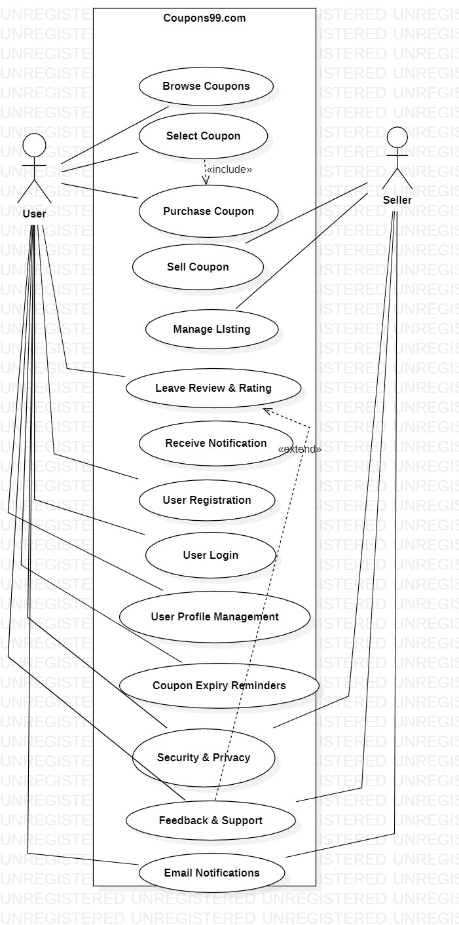

**3.6.4 Object-oriented Diagram**

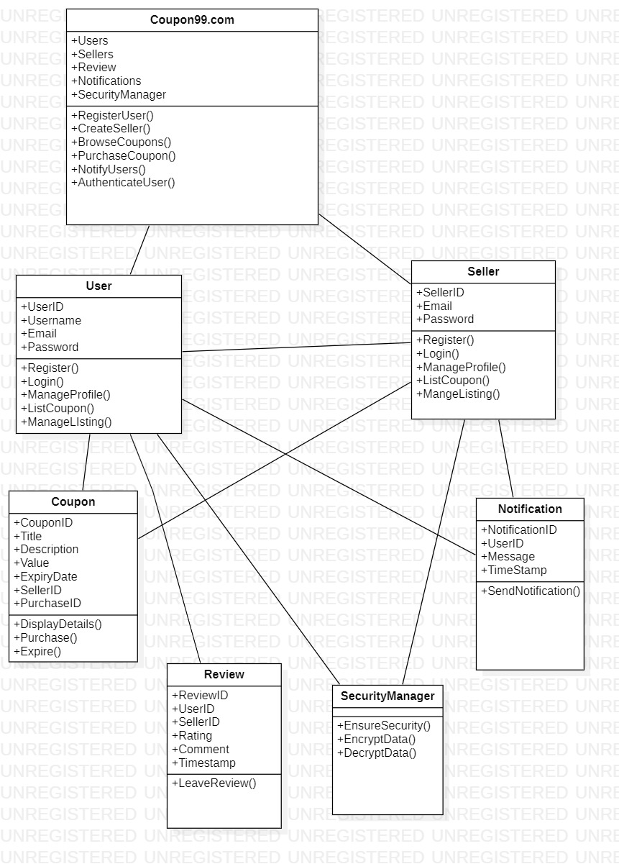

**3.6.5 System FlowCharts**

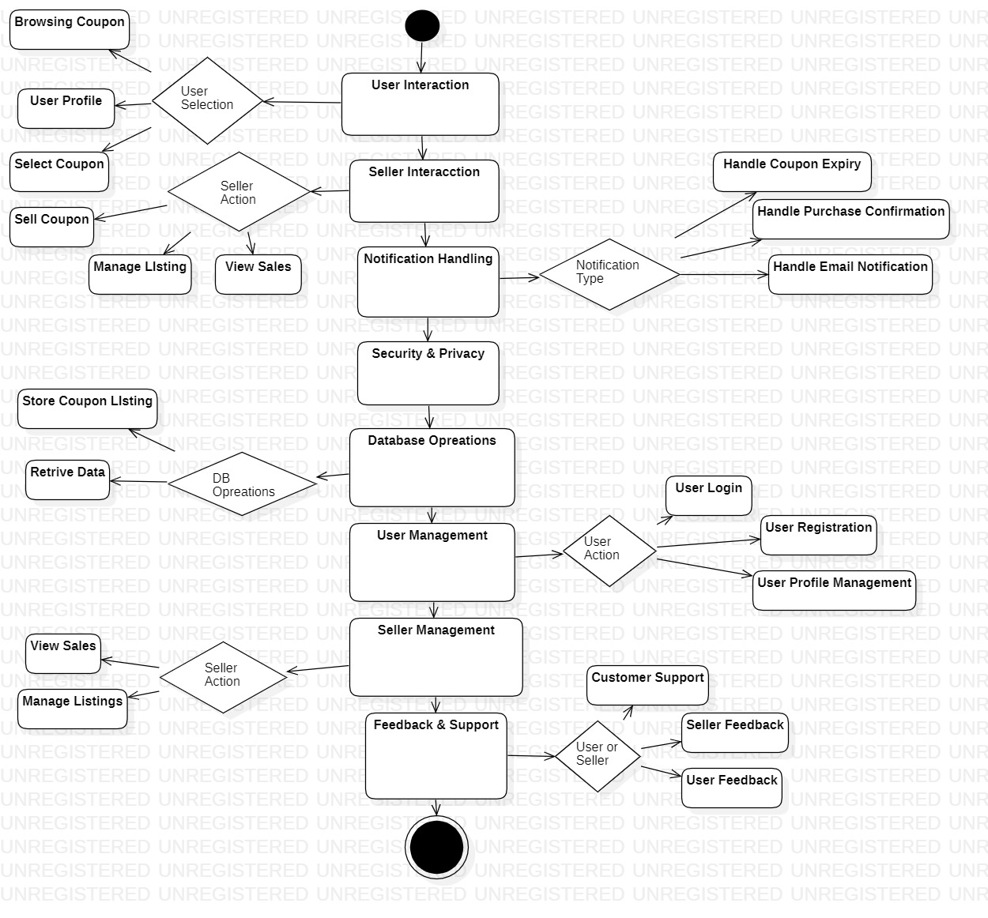

**Chapter 4**

**System Design**

**4.1 BASIC MODEL**

* **User Registration and Profiles:** Allow users to create accounts with their personal information and contact details.Provide user profiles where they can manage their listings, purchases, and sales history.
* **Coupon Listings :** Enable sellers to list coupons for sale, including details such as discount value, validity period, terms, and conditions.Categorize coupons based on brands or product types.
* **Search and Filters:** Implement search functionality to help users find specific coupons quickly. Provide filters such as category, brand, discount amount, and expiration date to refine search results.
* **Coupon Expiry Reminders:** Alert users before their purchased coupons are about to expire.
* **Featured Coupons:** Showcase select coupons on the homepage to highlight attractive deals and encourage exploration.
* **Real-time Notifications:** Notify users about their transactions, including purchase confirmations, coupon listing approvals, and successful sales.
* **User Ratings and Reviews:** Allow buyers to rate and leave reviews for sellers based on their experiences.Enable sellers to build credibility and trust through positive feedback.
* **User Notifications:** Send email notifications for new listings, price changes, or relevant updates.
* **Social Sharing:** Allow users to share their favorite coupons or successful purchases on social media platforms.
* **Responsive Design:** Ensure the website is responsive and mobile-friendly for a seamless user experience on different devices.
* **Privacy and Security:** Implement security measures to protect user data and financial information.
* **Multi-Language Support:** Provide support for multiple languages to cater to a diverse user base.

**4.2 DATA MODEL**

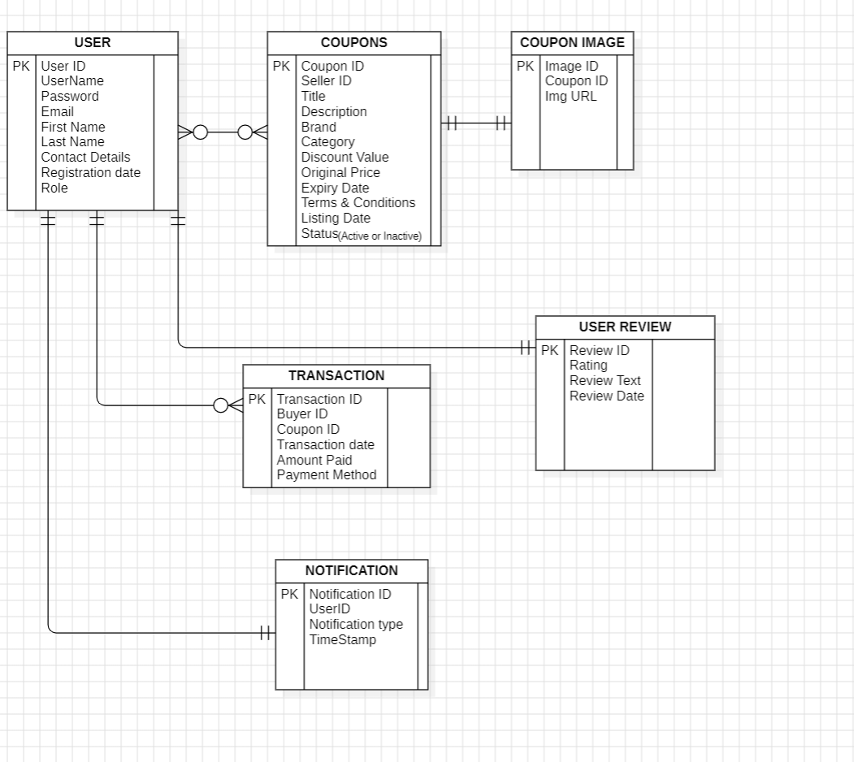

**4.2.2 Data integrity and constraints**

* **Primary Key Constraints:**

Ensure that each table has a primary key constraint that uniquely identifies each row in the table. For example, in the "User" table, the "UserID" field should be a primary key.

* **Foreign Key Constraints:**

Use foreign key constraints to maintain referential integrity between related tables. For example, the "SellerID" in the "Coupon" table should be a foreign key referencing the "UserID" in the "User" table.

* **Unique Constraints:**

Enforce uniqueness for certain columns to prevent duplicate data. For instance, the "Username" and "Email" fields in the "User" table should have unique constraints to ensure that no two users have the same username or email.

* **Check Constraints:**

Implement check constraints to enforce specific rules on data. For example, you can use a check constraint to ensure that the "Discount Value" in the "Coupon" table is greater than or equal to 0.

* **Default Constraints:**

Set default values for fields that have common or default values. For instance, you can set a default value of "Active" for the "Status" field in the "Coupon" table.

* **Not Null Constraints:**

Ensure that essential fields cannot have null values. Fields like "Username," "Password," and "Email" in the "User" table should have not null constraints.

* **Cascade Deletes and Updates:**

When using foreign keys, consider using cascade delete and update options to automatically propagate changes in related tables. For instance, if a user is deleted, you may want to cascade delete their associated coupons and reviews.

* **Indexes:**

Create indexes on columns frequently used in queries to improve query performance. For example, you can create indexes on columns used in search, filtering, or sorting, such as "Username" or "Coupon Title."

* **Triggers:**

Use triggers to enforce complex business rules and maintain data integrity. For instance, you can create a trigger to automatically update the "Listing Date" in the "Coupon" table when a new coupon is added.

* **Data Validation:**

Implement application-level data validation to ensure that data entered by users meets specific criteria. For example, validate that the "Expiration Date" is in the future when a coupon is added.

**4.3 Procedural data design**

* **User Registration and Profile Management:**
* Procedure for user registration, including capturing user details and creating a new user record in the "User" table.
* Procedures for users to update their profiles, including changing contact details, password, or other personal information.
* **Coupon Listing and Management:**
* Procedure for sellers to create new coupon listings, specifying details like title, brand, discount value, and expiration date. This involves inserting a new record into the "Coupon" table.
* Procedures for sellers to update or deactivate their coupon listings.
* Procedures for buyers to view and search for available coupons.
* **Coupon Purchase:**
* Procedure for a buyer to select and purchase a coupon. This involves inserting a new record into the "Transaction" table.
* Procedures for updating the status of a coupon to "Inactive" after purchase to prevent further transactions.
* **Coupon Image Management:**

Procedure for sellers to upload images associated with their coupon listings, which involves inserting records into the "CouponImage" table.

* **User Review and Rating:**

Procedure for users to leave reviews and ratings for other users or sellers. This

includes adding a new record to the "UserReview" table.

* **Notification Management:**

Procedures for sending notifications to users, including creating new records in the "Notification" table with appropriate message content.

Procedures for users to view their notifications.

* **Security and Data Validation:**
* Implement procedures for data validation to ensure that data entered by users adheres to specific criteria (e.g., checking the format of email addresses, validating coupon expiration dates).
* Implement security procedures to protect sensitive data, such as hashing passwords before storing them in the database.
* **Search and Filter Coupons:**

Implement search and filter procedures to allow users to find specific coupons based on criteria like brand, category, discount amount, and expiration date.

* **Handling Transactions:**

Procedures for handling financial transactions, including interfacing with payment gateways and recording transaction data in the "Transaction" table.

* **Real-time Notifications:**

Procedures for sending real-time notifications to users for events like successful purchases, coupon listing approvals, and more.

* **User Role Management:**

Procedures for differentiating between regular users and sellers based on user roles, allowing or restricting access to specific features.

* **Internationalization (Multi-Language Support):**

Procedures for rendering the website in multiple languages based on user preferences.

* These procedures will serve as the backbone of the application's functionality, allowing users to interact with the data, manage their profiles, buy and sell coupons, and receive notifications. Procedural data design is closely tied to the application's functionality and helps ensure that users can perform tasks effectively and securely within the Coupons99 platform.

**4.4 Logical Design**

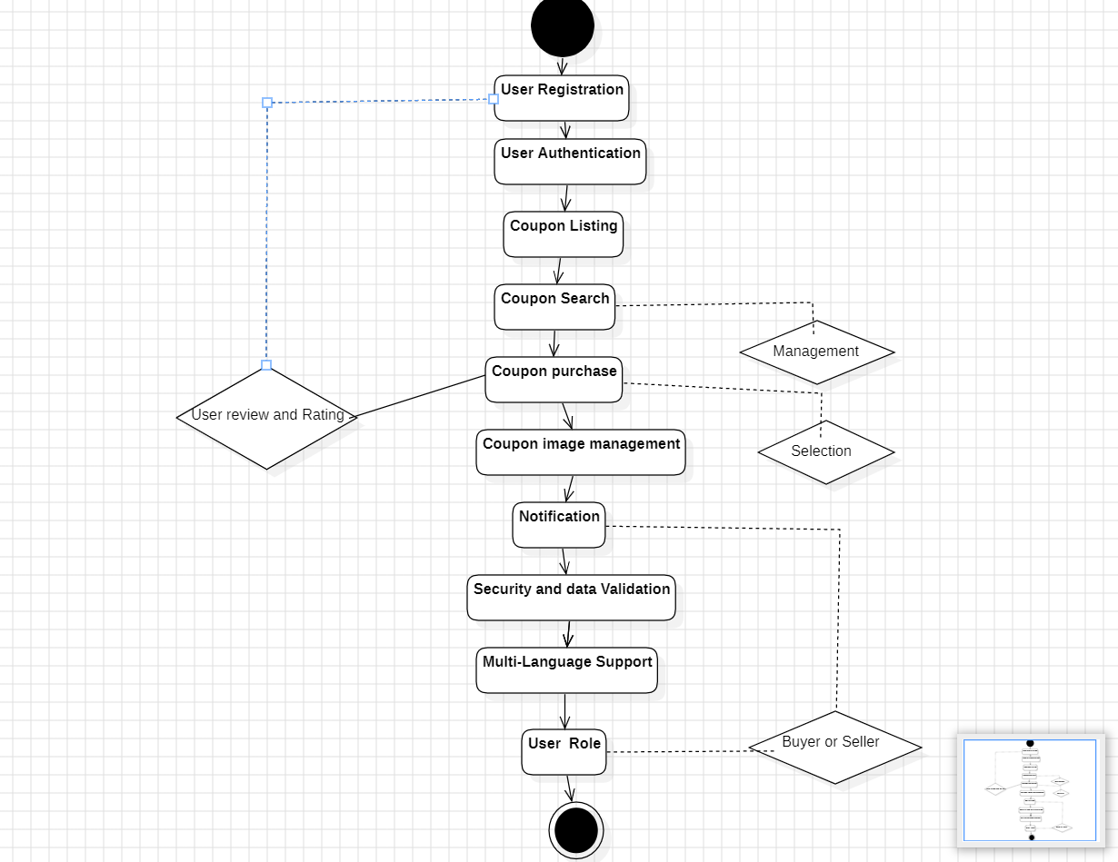

**4.5 Data Structure Daigram**

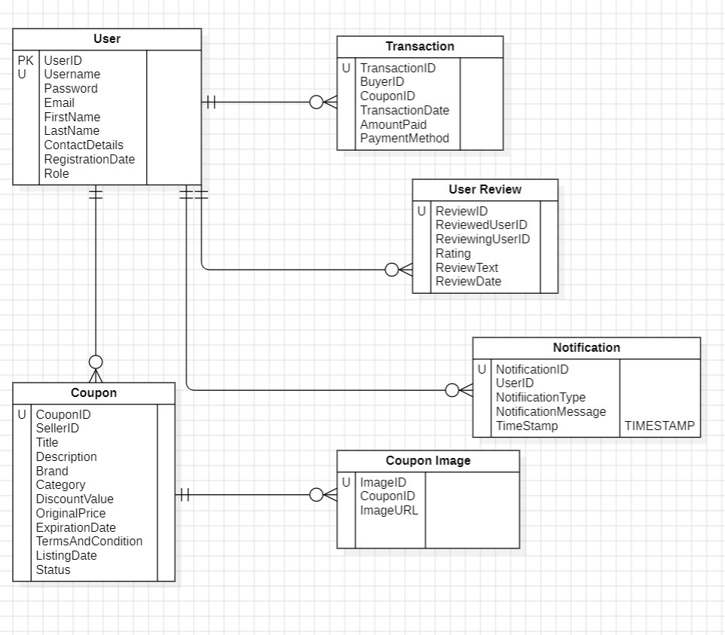

**4.6 Algorithms Design**

**1. User Registration and Profile Management:**

**Algorithm:**

1. Receive user registration details (username, password, email, first name, last name, contact details).

2. Validate user input (e.g., check for unique username and valid email).

3. If input is valid, create a new user profile in the database:

a. Generate a unique User ID.

b. Hash the user's password for security.

c. Record registration date.

d. Set the user role (User or Seller).

4. Return a registration confirmation to the user.

**2. Coupon Listing (Seller Perspective):**

**Algorithm:**

1. Sellers create a new coupon listing.

2. Validate coupon details (e.g., check for required fields).

3. If input is valid, create a new coupon listing in the database:

a. Generate a unique Coupon ID.

b. Record the seller's ID.

c. Set the coupon status to "Active."

4. Return a confirmation to the seller.

**3. Coupon Purchase (Buyer Perspective):**

**Algorithm:**

1. Sellers upload images for a coupon.

2. Validate the image and the associated coupon.

3. Store the image and link it to the coupon listing in the database.

4. Return an image upload confirmation to the seller.

**Pseudocode for a simplified algorithm to calculate the average of a list of numbers:**

**Algorithm: Calculate Average**

Input:

- A list of numbers (list)

Output:

- The average of the numbers (average)

Procedure:

1. Initialize a variable sum to 0.0

2. Initialize a variable count to 0

3. For each number in the list:

a. Add the number to the sum

b. Increment the count by 1

4. If count is greater than 0:

a. Set the average to sum divided by count

5. Else:

a. Set the average to 0 (to avoid division by zero)

6. Return the average as the result

Example Usage:

- Input: [5, 10, 15, 20, 25]

- Output: Average is 15.0

**Pseudocode:**

**Algorithm: List a Coupon**

**Input:**

- Seller's user information (seller)

- Coupon details (title, brand, category, discount, expiration, terms)

- Coupon images (image1, image2, ...)

**Output:**

- Confirmation message

**Procedure:**

1. Validate seller's credentials and role (must be a seller).

2. Validate coupon details, ensuring all required information is provided.

3. Create a new coupon record in the database:

a. Generate a unique CouponID.

b. Associate the seller's UserID with the coupon.

c. Set the coupon's title, brand, category, and terms.

d. Set the discount value, original price, and expiration date.

e. Mark the coupon as "Active."

4. Upload and associate coupon images with the coupon:

a. For each image provided:

i. Generate a unique ImageID.

ii. Link the image to the CouponID.

iii. Store the image URL or binary data.

5. Send a confirmation message to the seller.

**4.7 USER INTERFACE DESIGN**

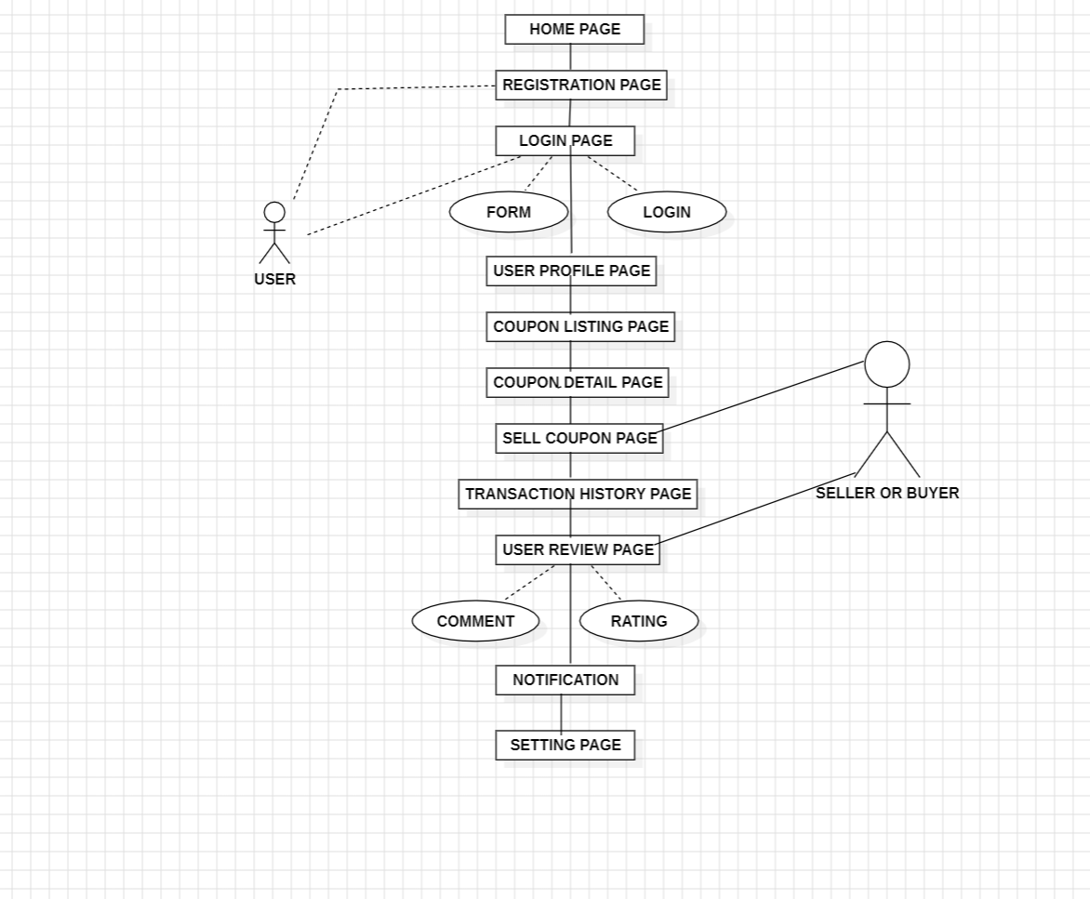

**4.8 SECURITY ISSUES**

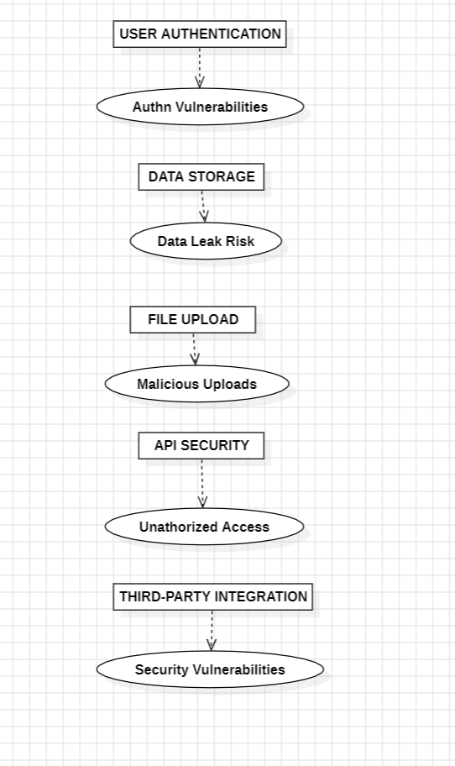

**4.9 TEST CASES DESIGN**

|  |  |  |  |  |  |
| --- | --- | --- | --- | --- | --- |
| **Test ID** | **Test Case** | **Test Description** | **Pre Condition** | **Test Steps** | **Expected Result** |
| TC-01 | User Registration | Verify that a new user can register successfully. | User navigates to the registration page. | 1. Enter valid user information (name, email, password).  2. Click the "Register" button. | User is registered, and their account is created. |
| TC-02 | Browse Coupons | Verify that users can browse and search for coupons. | User is on the homepage. | 1. Click on the "Browse Coupons" link.  2. Use the search bar to search for a specific coupon. | User can see a list of coupons and search for specific ones. |
| TC-03 | Purchase Coupon | Verify that a user can successfully purchase a selected coupon. | User has selected a coupon for purchase. | 1. Click the "Purchase" button on a selected coupon.  2. Enter valid payment information.  3. Click the "Confirm Purchase" button. | User is notified of the successful purchase, and the coupon is added to their account. |
| TC-04 | Sell Coupon | Verify that a seller can create and list coupons for sale. | Seller is logged in and on their profile. | 1. Click on the "Sell Coupon" option.  2. Fill out the coupon details (discount value, terms, expiration date, etc.).  3. Click the "List Coupon" button. | The coupon is successfully listed for sale. |
| TC-05 | User Reviews | Verify that users can leave reviews and ratings for sellers. | User has purchased a coupon from a seller. | 1. Go to the seller's profile or the purchased coupon.  2. Leave a review and rating. | Review and rating are successfully submitted and visible. |
| TC-06 | Cross-Browser Compatibility | Verify that the platform functions correctly on different web browsers. | User accesses the platform from different web browsers (e.g., Chrome, Firefox, Edge, Safari). | 1. Open the platform in various browsers.  2. Verify that all features and functionalities | The platform is compatible with a range of web browsers. |
| TC-07 | Mobile App Compatibility | Verify that the mobile app version functions correctly. | User accesses the platform through the mobile app. | 1. Use the mobile app to perform core tasks (e.g., browse coupons, purchase, and leave reviews). | The mobile app functions seamlessly. |

# CHAPTER 5 IMPLEMENTATION & TESTING

#### Code

* + - **User Authentication:** Implementing user authentication functionality is crucial for most web applications. This involves allowing users to register, log in, and log out securely. During this phase, you would create forms for user registration and login, handle form submissions, and integrate authentication mechanisms such as password hashing and session management.

#### Code Snippet :

// Registration form submission

$("#registration-form").submit(function (event) { event.preventDefault();

// Get user registration data from form fields var userData = {

"username": $("#reg-username").val(),

"password": $("#reg-password").val(),

"email": $("#email").val(),

"number": $("#number").val()

};

// Send AJAX request to register user

// Handle success and error responses accordingly

});

// Login form submission

$("#login-form").submit(function (event) { event.preventDefault();

// Get username and password from form fields var username = $("#login-username").val(); var password = $("#login-password").val();

// Send AJAX request to authenticate user

// Handle success and error responses accordingly

});

50

* + - **Coupon Management:** Since your application revolves around coupons, you'll need robust functionality for managing coupons. This includes adding new coupons, editing existing ones, and deleting coupons. You would create forms for adding and editing coupons, implement server-side logic to handle these operations, and ensure proper validation of coupon data.

#### Code Snippet :

// Add coupon form submission

$("#add-coupon-form").submit(function (event) { event.preventDefault();

// Get coupon data from form fields var couponData = {

"title": $("#coupon-title").val(), "description": $("#coupon-description").val(),

// Include other coupon details as needed

};

// Send AJAX request to add coupon

// Handle success and error responses accordingly

});

* + - **Coupon Display:** Displaying coupons to users is another core aspect of your application. You'll need to fetch coupon data from your backend database and present it to users in a user-friendly manner. This could involve creating HTML templates for displaying coupons, fetching coupon data from the server using AJAX requests, and dynamically updating the UI based on the retrieved data.

#### Code Snippet :

$(document).ready(function () {

$.ajax({

url: "http://localhost:8080/findall", type: "POST",

success: function (coupons) {

var container = $('#coupons-container'); container.empty(); coupons.forEach(function (coupon) {

var div = $('<div>').addClass('coupon'); div.append($('<h3>').text(coupon.couponTitle));

if (coupon.imageUrl) div.append($('<img>').attr("src", "coupon99/CouponImages/" + coupon.imageUrl));

div.append($('<h3>').text("₹" + coupon.price)); div.append($('<p>').text(coupon.description)); div.append($('<button>').addClass('action-button get-coupon-

button').text('Get this Coupon').on('click', (function (couponCopy) { return function () {

51

redeemCoupon(couponCopy);

}

})(coupon))); container.append(div);

});

},

error: function (jqXHR, textStatus, errorThrown) { console.error("Error loading coupons: ", textStatus, errorThrown);

}

});

});

* + - **Search Functionality:** Implementing search functionality allows users to find coupons based on specific criteria, such as keywords or categories. During this phase, you would create a search form where users can input their search queries, handle search requests on the server side, and update the UI to display search results.

#### Code Snippet :

// Search input event listener

$("#searchInput").on('input', function () {

// Get search query from input field var query = $(this).val();

// Send AJAX request to search coupons with the provided query

// Handle success and error responses accordingly

});

* + - **UI/UX Enhancements:** While not strictly functional, enhancing the user interface and user experience is essential for the success of your application. This could involve refining the design of your application, adding animations or transitions to improve interactivity, and ensuring responsiveness across different devices and screen sizes.
    - **Testing and Debugging:** Throughout the coding phase, it's crucial to continuously test your application and debug any issues that arise. This involves both manual testing by interacting with your application as a user would and automated testing using tools and frameworks appropriate for your technology stack.

52

#### Testing Approach

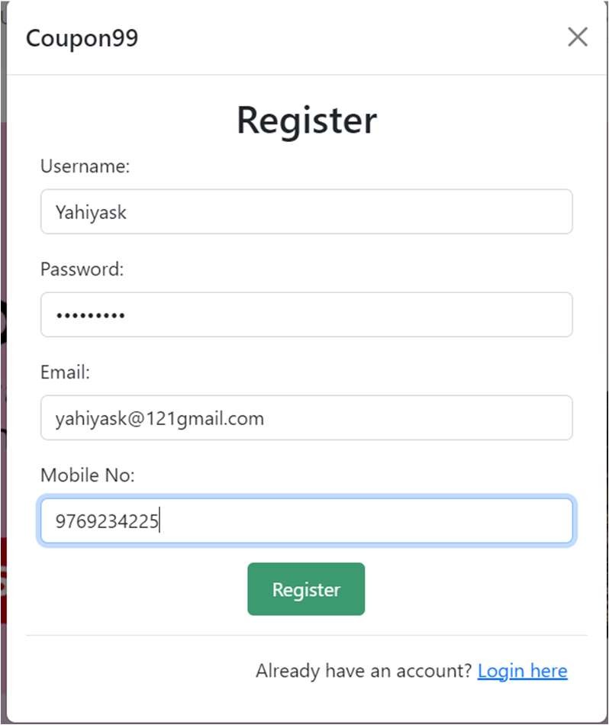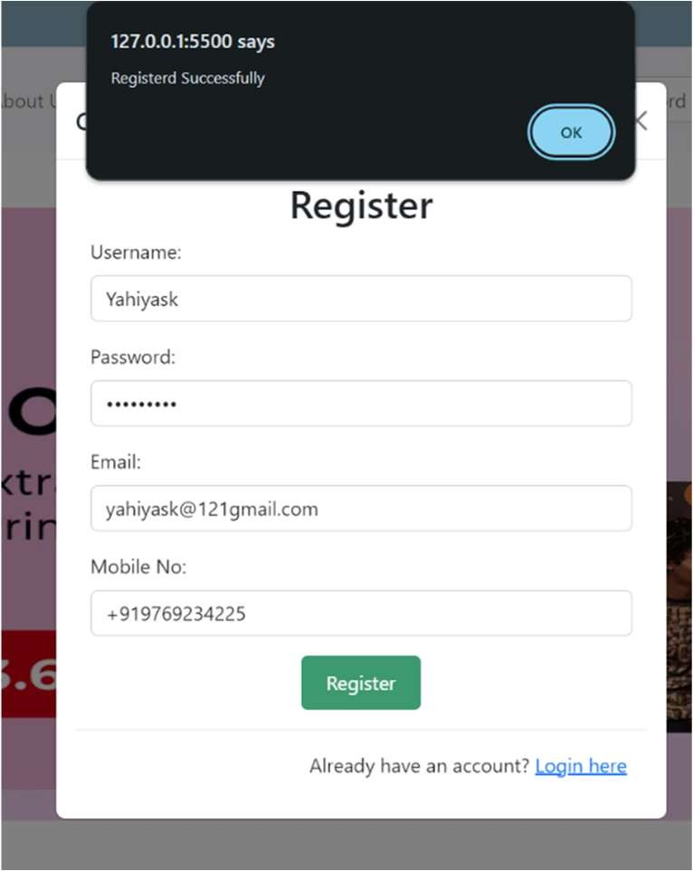

The testing approach for the Coupons99.com involves verifying the functionality, reliability, and usability of the software to ensure it meets the requirements and expectations of users.

#### User Registration

Verify that a new user can register successfully.

#### Pre conditions :

User navigates to the registration page.

#### Test Steps :

* 1. Enter valid user information (username, contact no, email, password).
  2. Click the "Register" button.

#### Expected Result :

User is registered, and their account is created.

#### Test Result :

53

#### Browse Coupons

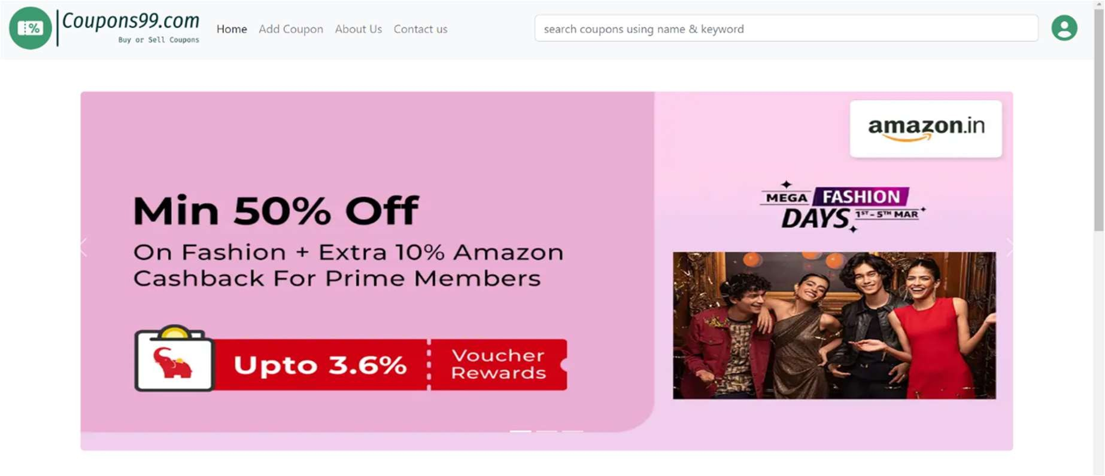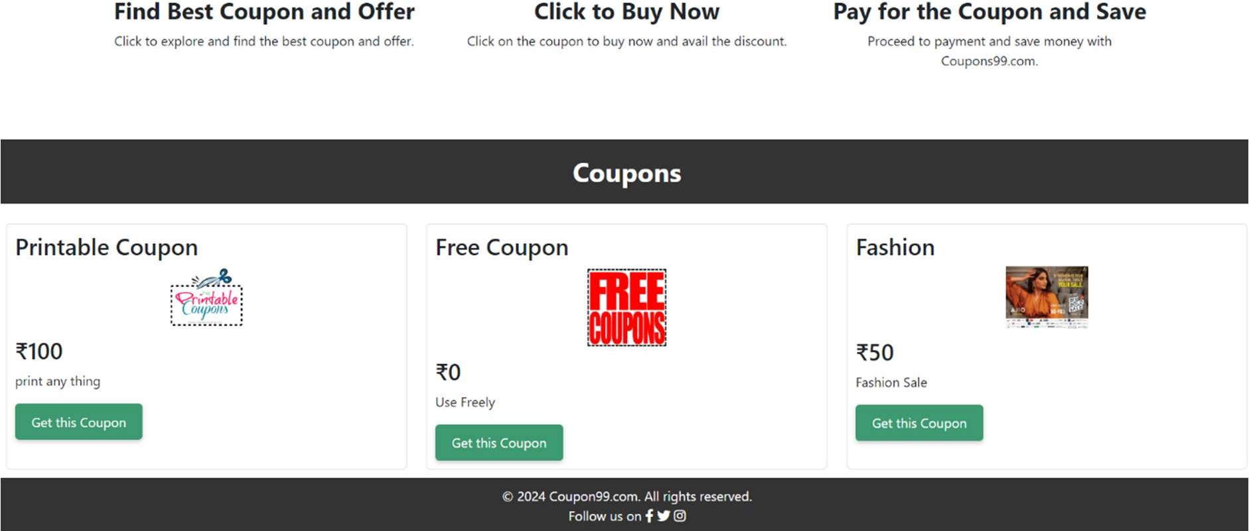

Verify that users can browse and search for coupons.

#### Pre conditions :

User is on the homepage

#### Test Steps :

* 1. Click on the "Browse Coupons" link.

#### Expected Result :

User is registered, and their account is created.

#### Test Result :

54

#### Purchase Coupon

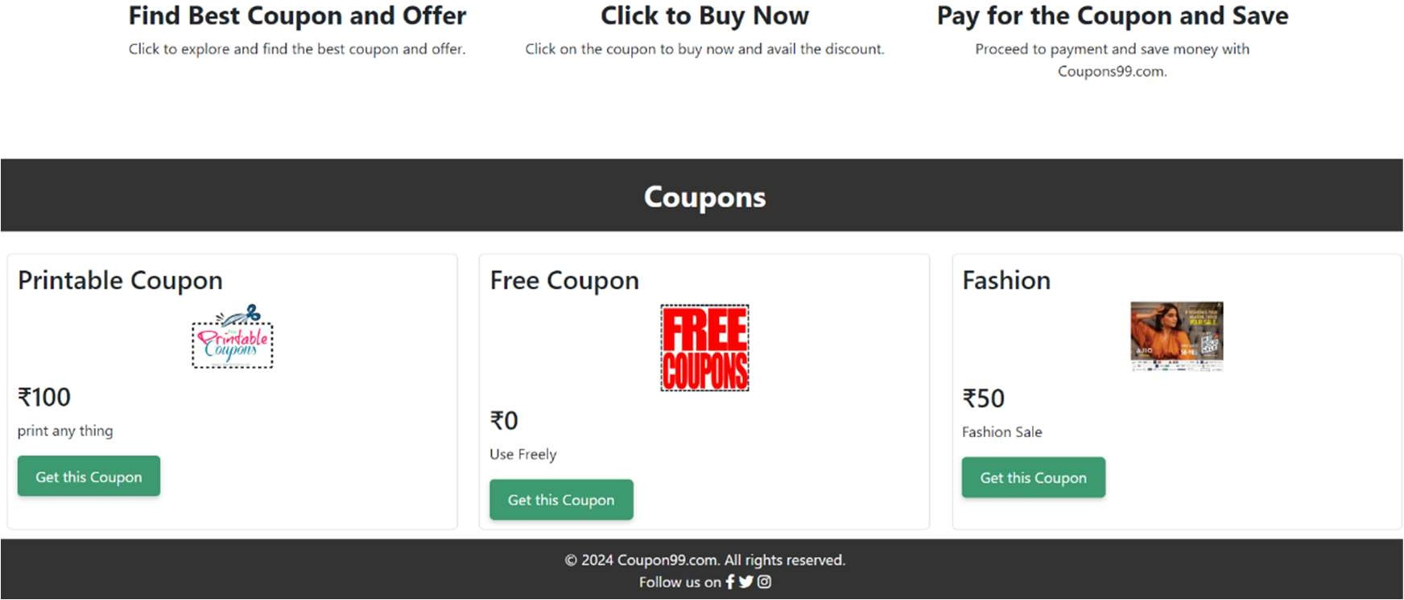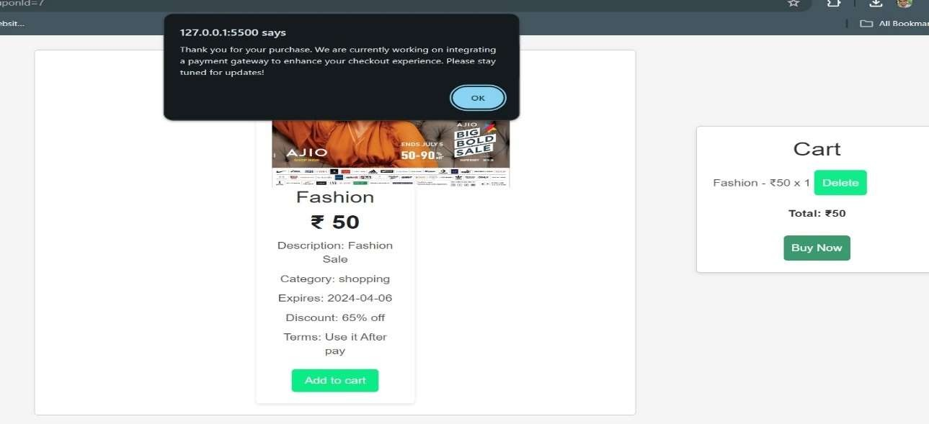

Verify that a user can successfully purchase a selected coupon.

#### Pre conditions :

User has selected a coupon for purchase.

#### Test Steps :

* 1. Click the "Add to Cart" button on a selected coupon.
  2. Click the "Buy Now" button.
  3. Then get a alert box.

#### Expected Result :

User is notified of the successful purchase, and the coupon is added to their account.

#### Test Result :

55

#### Sell Coupon

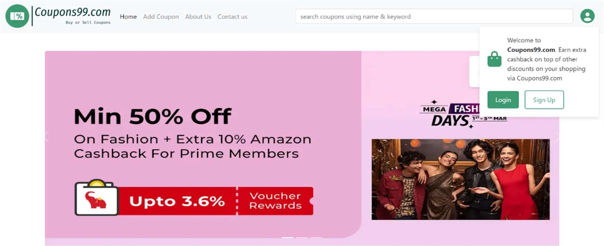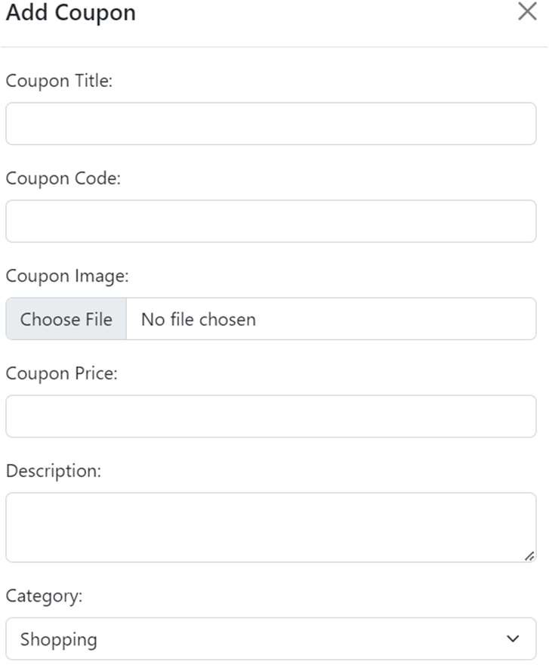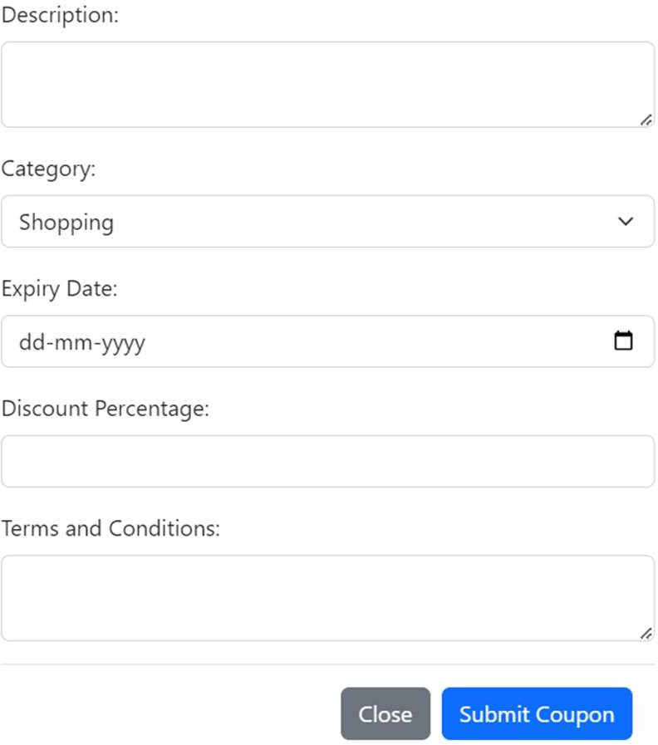

Verify that a seller can create and list coupons for sale.

#### Pre conditions :

Seller is logged in and on their profile

#### Test Steps :

* 1. Click on the "Add Coupon" option.
  2. Fill out the coupon details (Coupon title ,discount value, terms, expiration date, etc.).
  3. Click the "Sumbit Coupon" button.

#### Expected Result :

The coupon Added successfully listed for sale.

#### Test Result :

56

#### Cross-Browser Compatibility

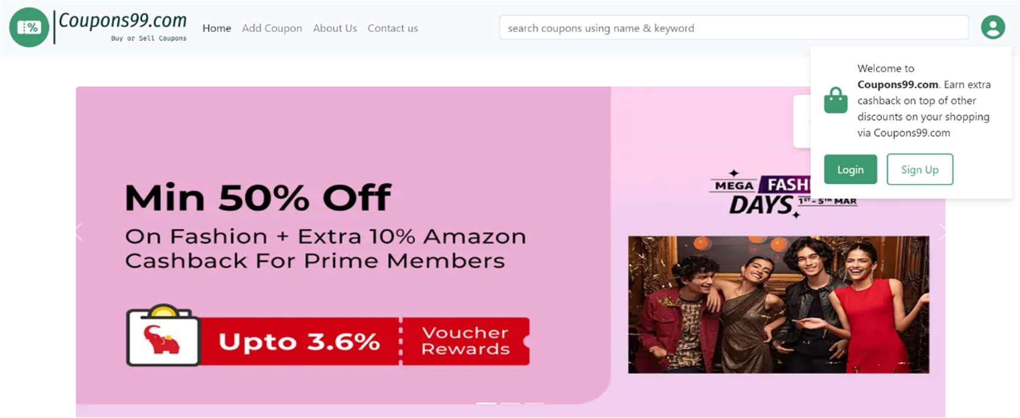

Verify that the platform functions correctly on different web browsers.

#### Pre conditions :

User accesses the platform from different web browsers (e.g., Chrome, Firefox, Edge, Safari).

#### Test Steps :

* 1. Open the platform in various browsers.
  2. Verify that all features and functionalities The platform is compatible with a range of web browsers.

#### Expected Result :

The platform is compatible with a range of web browsers.

#### Test Result :

57

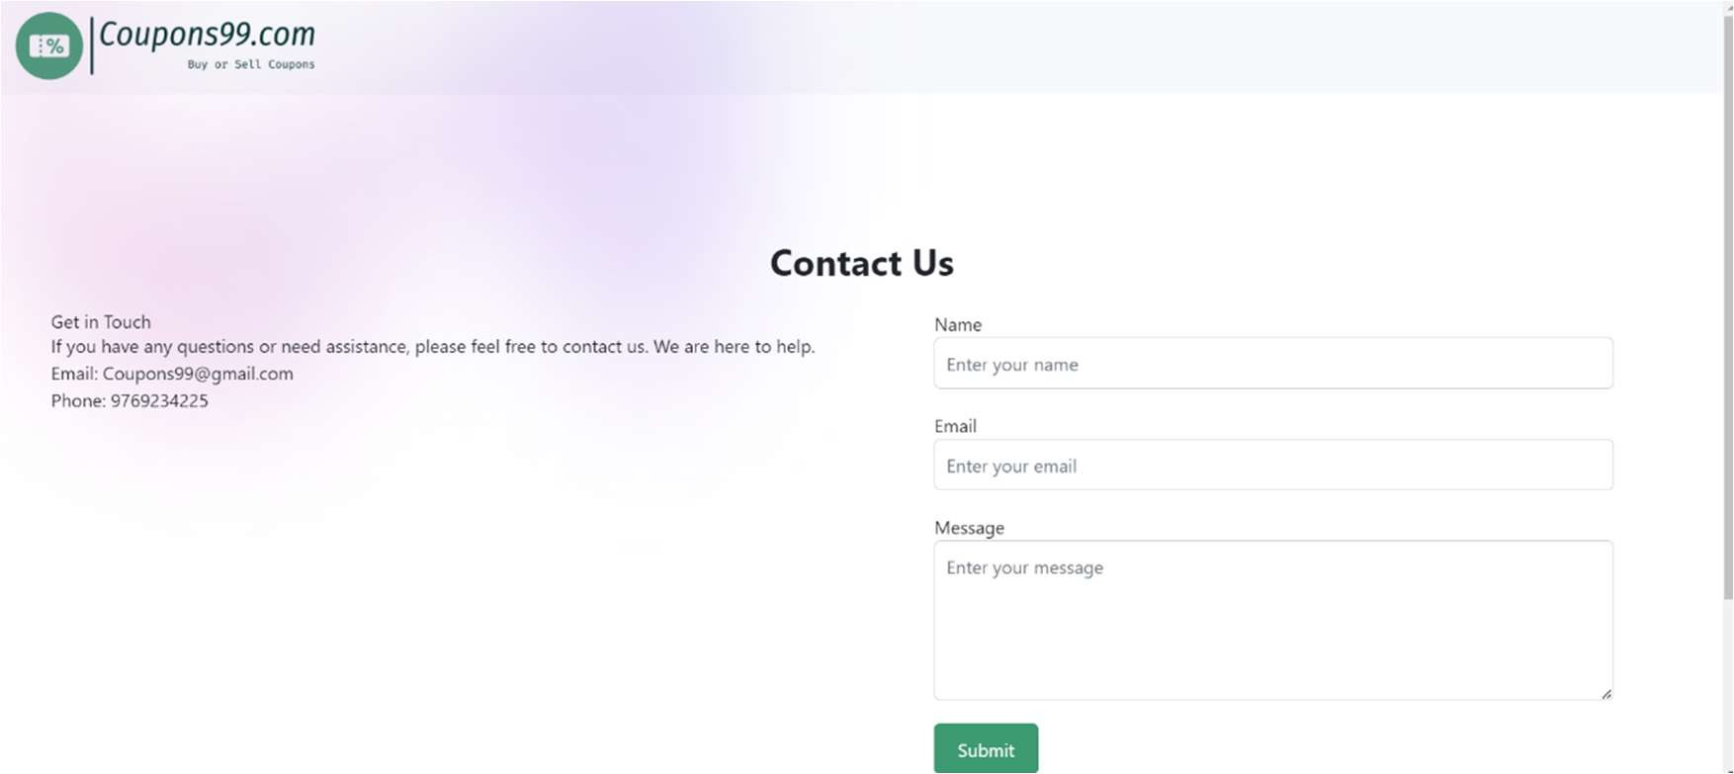

58

# CHAPTER 6 RESULT ANS DISCUSSION

#### Test Report for Coupons99.com Project

**Project Overview:**

Coupons99.com aims to create a centralized platform for buying, selling, and trading digital payment coupons. The project focuses on providing users with a user-friendly interface, diverse coupon options, and features such as real-time notifications and multi-language support.

#### Test Objectives:

Ensure the functionality of key features like user registration, coupon listings, search functionality, and notifications.

Validate the security measures implemented to protect user data and financial information. Assess the responsiveness and usability of the website across different devices.

Verify the accuracy of coupon expiry reminders and featured coupon showcases.

#### Test Environment:

Operating Systems: Windows, macOS, iOS, Android

Browsers: Google Chrome, Mozilla Firefox, Safari, Microsoft Edge Devices: Desktops, Laptops, Tablets, Smartphones

59

#### Test Cases and Results:

**User Registration and Profiles:**

Test Case: Register a new user account with valid credentials. Result: Registration successful. User profile created without errors. **Coupon Listings:**

Test Case: Add a new coupon listing with all required details.

Result: Coupon successfully listed with accurate information displayed.

#### Search and Filters:

Test Case: Search for a specific coupon using search functionality and apply various filters. Result: Coupons found matching search criteria. Filters refine search results effectively.

#### Coupon Expiry Reminders:

Test Case: Purchase a coupon and verify receipt of expiry reminder notification. Result: Expiry reminder received before the coupon's validity period ends.

#### Featured Coupons:

Test Case: Check homepage for featured coupons and verify their visibility. Result: Featured coupons displayed prominently on the homepage as expected. **Real-time Notifications:**

Test Case: Complete a transaction and verify the receipt of real-time notification. Result: Transaction confirmation received promptly through real-time notification. **Security Measures:**

Test Case: Attempt unauthorized access to user data or financial information. Result: Security measures prevent unauthorized access. User data remains protected.

60

#### Responsive Design:

Test Case: Access the website from different devices and screen sizes.

Result: Website displays properly and functions smoothly across various devices.

### User Documentation for Coupons99.com

Welcome to Coupons99.com!

Thank you for choosing Coupons99.com, your one-stop destination for buying, selling, and trading digital payment coupons. This user documentation aims to guide you through the features and functionalities of our platform to ensure a seamless experience.

Table of Contents: Introduction Getting Started

User Registration and Profiles Coupon Listings

Search and Filters

Coupon Expiry Reminders Featured Coupons

Real-time Notifications Security Measures Responsive Design Conclusion

1. Introduction:

61

Coupons99.com is designed to provide you with a convenient platform to access a wide range of coupons, discounts, and exclusive offers. Whether you're a buyer looking for great deals or a seller wanting to make use of unused coupons, Coupons99.com has you covered.

1. Getting Started:

To get started, simply visit Coupons99.com and create your account. Click on the "Sign Up" button and fill in the required details. Once registered, you can log in using your credentials and start exploring the platform.

1. User Registration and Profiles:

Upon registration, you'll have access to your user profile. Here, you can manage your listings, purchases, and sales history. Update your personal information and contact details as needed to ensure smooth transactions.

1. Coupon Listings:

As a seller, you can list your coupons for sale by providing details such as discount value, validity period, and terms and conditions. Buyers can browse through listings and select coupons that best suit their needs.

1. Search and Filters:

Use the search functionality to quickly find specific coupons. Refine your search results using filters such as category, brand, discount amount, and expiration date to narrow down your options.

62

1. Coupon Expiry Reminders:

Never miss out on using your coupons with our expiry reminder feature. Receive notifications before your purchased coupons are about to expire, ensuring you make the most of your savings.

1. Featured Coupons:

Explore our homepage to discover featured coupons showcased to highlight attractive deals and encourage exploration. Keep an eye out for these special offers to maximize your savings.

1. Real-time Notifications:

Stay informed about your transactions with real-time notifications. Receive purchase confirmations, coupon listing approvals, and successful sales notifications promptly to track your activities on the platform.

1. Security Measures:

Rest assured that your data and financial information are protected with our robust security measures. We prioritize the security of your information to ensure a safe and secure shopping experience.

1. Responsive Design:

63

Enjoy a seamless user experience across different devices with our responsive design. Whether you're accessing Coupons99.com from your desktop, laptop, tablet, or smartphone, the website will adapt to your screen size for optimal viewing.

1. Conclusion:

Coupons99.com is committed to revolutionizing coupon exchange by providing a dynamic and user-friendly platform. We strive to enhance your shopping experience by offering a wide range of coupons, real-time notifications, and top-notch security measures. Join us today and start saving money on your purchases!

Thank you for choosing Coupons99.com. Happy shopping!

64

# CHAPTER 7 CONCLUSIONS

## Conclusion of Coupons99.com Project

Coupons99.com represents a significant milestone in the realm of digital coupon exchanges, offering a comprehensive solution to the challenges faced by traditional methods. Through meticulous planning, development, and testing, the project has successfully addressed the needs of both buyers and sellers in the coupon ecosystem. Here are the key points highlighting the conclusion of Coupons99.com:

**Innovative Solution**: Coupons99.com introduces an innovative and user-friendly platform for buying, selling, and trading digital payment coupons. By centralizing these activities, the project eliminates the inefficiencies and inconveniences associated with manual coupon exchanges.

**Convenience and Efficiency:** The primary objective of Coupons99.com is to provide users with a convenient and efficient way to access discounts and unlock the value of unused coupons. Through features like user-friendly interface, real-time notifications, and search filters, the platform streamlines the coupon exchange process, saving users time and effort.

**Enhanced User Experience:** With a focus on user experience, Coupons99.com offers a range of features designed to cater to the diverse needs of its users. From personalized user profiles to responsive design across various devices, the platform ensures a seamless and enjoyable experience for all users.

**Security and Trust:** Coupons99.com prioritizes the security of user data and financial information. Robust security measures are implemented to protect user privacy and build trust among users. Seller verification processes and real-time notifications further contribute to a secure and transparent environment.

**Future Expansion:** While Coupons99.com has achieved significant milestones, the project's journey does not end here. Future expansion plans include integrating secure payment

65

gateways, offering analytics and reporting tools for sellers, and enhancing customer support features to further elevate the platform's capabilities.

## Limitations of Coupons99.com System:

Despite its many strengths and innovative features, Coupons99.com, like any complex system, has certain limitations that users should be aware of. These limitations include:

**Limited Availability of Coupons**: While Coupons99.com aims to provide a wide range of coupons, there may be limitations on the availability of certain coupons. Users may not always find coupons for their preferred brands or products, especially for niche or less popular items.

**Dependence on Seller Listings**: The availability of coupons on Coupons99.com relies on sellers listing their coupons for sale. As a result, there may be fluctuations in the number and variety of coupons available at any given time, depending on seller activity.

**Risk of Expired or Invalid Coupons**: Despite efforts to ensure the accuracy of coupon listings, there is a risk that users may encounter expired or invalid coupons. Sellers may inadvertently list expired coupons, leading to disappointment for buyers who attempt to redeem them.

**Security Concerns:** While Coupons99.com implements robust security measures to protect user data and financial information, no system is entirely immune to security breaches. Users should exercise caution when sharing personal or sensitive information on the platform and ensure they follow best practices for online security.

**Dependency on Third-party Payment Gateways:** Coupons99.com relies on third-party payment gateways to facilitate transactions between buyers and sellers. Any disruptions or issues with these payment gateways could impact the ability of users to complete transactions on the platform.

**Geographic Limitations:** Certain coupons may be region-specific or limited to certain geographic locations. Users should be mindful of these limitations when browsing and purchasing coupons on Coupons99.com, especially if they intend to use them in a specific location.

66

**Reliance on User Reviews:** While user ratings and reviews can provide valuable insights into the quality of sellers and coupons, they may not always be entirely accurate or representative of every user's experience. Users should consider multiple factors when making purchasing decisions based on reviews.

**Technical Constraints:** Users may encounter technical issues or glitches while using Coupons99.com, such as website downtime, slow loading times, or compatibility issues with certain devices or browsers. The platform's technical support team works to address these issues promptly, but they may still impact the user experience.

Despite these limitations, Coupons99.com continues to strive for excellence in providing a convenient, efficient, and secure platform for coupon exchange. By remaining vigilant and responsive to user feedback, the platform aims to mitigate these limitations and enhance the overall user experience over time.

## Future Scope of Coupons99.com Project:

**Expansion of Coupon Offerings:** Coupons99.com can expand its offerings by partnering with more brands and retailers to provide a wider variety of coupons to users. This includes offering exclusive deals and discounts not available elsewhere, thereby attracting more users to the platform.

**Integration of AI and Machine Learning:** Implementing AI and machine learning algorithms can enhance the platform's capabilities in various ways. For instance, personalized coupon recommendations based on user preferences and behavior can improve user engagement and satisfaction.

**Enhanced User Analytics**: Coupons99.com can invest in advanced analytics tools to gather insights into user behaviour, coupon usage patterns, and market trends. This data can be utilized to optimize the platform, tailor promotions, and improve user targeting.

**Gamification Elements:** Introducing gamification elements such as reward points, badges, and leaderboards can incentivize user engagement and loyalty. Users could earn points for various actions on the platform, which can be redeemed for discounts or exclusive perks.

67

**Social Integration:** Integrating social media features can allow users to share their favourite coupons, purchases, and reviews with their social networks. This not only increases user engagement but also serves as a form of word-of-mouth marketing for the platform.

**Enhanced Mobile Experience:** Investing in a dedicated mobile app for Coupons99.com can provide users with a seamless and optimized experience on their smartphones and tablets.

The app can leverage mobile-specific features such as push notifications and location-based services for enhanced convenience.

**Global Expansion:** Coupons99.com can explore opportunities for expansion into new markets beyond its current geographic reach. This involves localization efforts such as supporting multiple languages and currencies to cater to a diverse international user base.

**Partnerships with Financial Institutions:** Collaborating with banks, credit card companies, and other financial institutions can unlock new avenues for offering exclusive discounts and promotions to users. Co-branded campaigns and partnerships can benefit both Coupons99.com and its financial partners.

**Integration with Retail Loyalty Programs:** Integrating Coupons99.com with existing retail loyalty programs can provide added value to users by allowing them to earn rewards or points for using coupons on the platform. This fosters stronger ties between Coupons99.com and its partner retailers.

**Expansion into Other Verticals:** Beyond digital payment coupons, Coupons99.com can explore opportunities to expand into other verticals such as travel deals, restaurant discounts, or entertainment offers. This diversification can attract new users and broaden the platform's appeal.

By embracing these future scope initiatives, Coupons99.com can continue to evolve and innovate, cementing its position as a leading destination for savvy shoppers seeking the best deals and discounts.

68